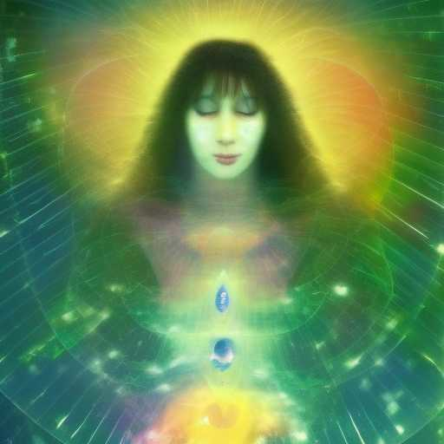
THE HOLOGRAPHIC LADDER

You have beckoned me from the space between your very breaths,
She said
You loved me above all others, so I
manifested to you as an inter-dimensional hologram

“I am the feelings you want to have”

She is the ascent and descent of the Spirit. She is Jacob's Ladder through the Womb of Compassion

